Smart waste management system

# Team ID : PNT2022TMID43525

|  |  |  |
| --- | --- | --- |
| STEP 1 | STEP 2 | STEP 3 |
| Problem Solving Cards -Basic question | Framing Statements | Ideas |
| *Problem Statement |  | Problem Solution |

1. 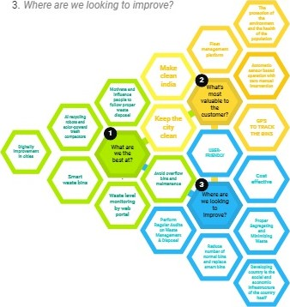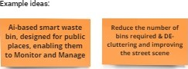_ Whats most valuable to the customer?

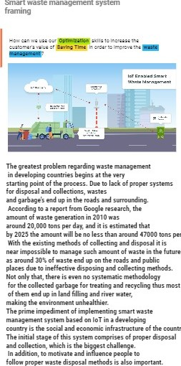

system

—try

it*lf.

1. What are we the best at?

3_ Where are we looking to improve?

Previously there were numerous initiatives on waste management and educating people to dispose waste properly, and as they failed to achieve significant results, we have figured out the scopes that could be develop. To solve this problem, we have designed a process that ensures proper disposal and efficient waste collection. The procedures we designed involves creative initiative that will inspire people to dump in designated area or bins, and innovative method by using Decreasing Time algorithm or DTA for day.

monitoring garbage generation and collection of the garbage's.